Visualization of Comfort and Reach in Cab Environment
Daniel Lundström^{a,d}, Tuomas Nevaranta^{b}, Lars Hanson^{c}, Dan Högberg^{d} och Anders Sundin^{e}
a, Industrial Design, Department of Design Sciences, Lund University, Lund, Sweden
b, Valtra Inc., Suolahti, Finland
c, Ergonomics, Department of Design Sciences , Lund University, Lund, Sweden
d, School of Technology and Society, University of Skövde, Skövde, Sweden
e, Semcon Caran AB, Gothenburg, Sweden

Abstract
The aim of this work is to respond to shortcomings in tractor cab layout design by deriving a working process for the creation of visual guidelines of comfort and comfortable reach, i.e. comfort and reach envelopes. This working process was the result of an illustrative case, where reach and comfort envelopes were created with the help of digital human modeling programs as well as CAD software for the tractor developer and manufacturer Valtra Inc. The conclusion of the study is that better target group accommodative comfort and reach envelopes can improve cab layout design related to comfort and work safety. Moreover, a general working method allows for optimization of ergonomic requirements for the specific design by permitting full control of each work step.

Introduction
The operator of the modern tractor is subjected to full body vibrations, prolonged sitting and twisted postures, which have all been shown to increase the risk of experiencing lower back pains as well as attaining hip joint arthritis (Torén et al., 1999). Moreover, monotonous movements and short repeated working cycles, e.g. operating and reaching for controls, are constantly present in tractor operation and are probably the main reasons for stress and fatigue injuries among drivers (Nilsson, 2001).

In order to design for comfort and reduce work-related disorders among tractor drivers Zimmerman et al. (1997) propose to address four main design criteria: minimizing magnitude and frequency of vibration reaching the operator; locating controls optimally to minimize reach distances, trunk flexion and trunk rotation; providing maximum operator visibility from an upright supported seated posture; and taking regular breaks to minimize the effects of sustained postures.

Even though the importance of designing for operator comfort and safety is well recognized, sources report on deficiencies in implementing the criteria set out by Zimmerman related to tractor cab design. Drakopoulos and Mann (2007) found that 89% of controls were situated on the right-hand side of the workstation, but only 75% of controls were located within the functional reach of the operator. Traditionally determining functional reach for cab design has been informed by ISO standards and SAE recommendations, conveying percentile reach by visual reach envelopes. However, Hsiao et al. (2005) report on inadequacy in target group accommodation and representation in standards and guidelines for tractor and vehicle cab layout design.

In order to better respond to Zimmerman’s design criteria and address the issues of cab reach accommodation, there is a need for a working process for the creation and visualization of tractor operator reach and comfort independent of traditional standards and guidelines.

The aim of this work is to respond to this demand and develop a working process for the purpose of optimizing driver comfort through reach and comfort envelopes. A case from the tractor manufacturer Valtra Inc., which designs and produces farm and forestry tractors, is used to derive and illustrate the resulting working process.

Method and Result
In order to establish a working process for the creation of more accommodative reach and comfort envelopes, an illustrative case was used with the purpose of deriving reach and comfort envelopes specific for the design work of Valtra. The work of deriving reach and comfort envelopes for Valtra was then used to deduce a more general and resulting working process.

For the method work, two human modeling software were used: Jack (Badler, 1993) and Ramsis (Seidl, 1994). The method work as well as the resulting working process are dictated by data and program features of these two programs.

Working process for deriving optimized reach and comfort envelopes (as result of illustrative case)

- Identification and generation of representative manikins.
  - Identify anthropometric data, i.e. target group data.
  - Identify task and useful anthropometric dimensions.
  - Optimize number of manikin representatives according to accommodation level and task.
- Posture prediction simulation in Ramsis.
  - Translate task(s) into geometrical targets.
  - Simulate posture in context of task constraints.
- Translation of posture and manikin data between Jack and Ramsis.
  - Translate/derive useful Jack manikin measurements from Ramsis anthropometrical data.
  - Create representatives in Jack with available anthropometric module.
  - Make posture translatable through *.iges geometrical landmark model.
  - Manually position corresponding manikin and posture in Jack to attain Ramsis posture.
- Generation of comfort envelopes.
  - Generate envelops of comfort in Jack for each manikin and posture.
  - Find union of surface- coordinates of comfort envelopes with MatLab script.
  - Represent union of comfort by adding mesh surfaces to coordinate space.
- Generation of reach envelopes.
  - Generate reach envelopes for every manikin and posture in Ramsis.
  - Trim reach zones in order to find smallest common volume.
- Assembly of visual guideline.

Illustrative case (used to derive the working process)

1. Identification and generation of representative manikins.

Valtra sells tractors all over the world but primarily focus on Scandinavian and German markets. As no data of mixed nationality matching Valtra’s targeted drivers in various countries were available, a simplification using only German anthropometry available in Ramsis was implemented. Using the German database of Ramsis also meant a short cut could be taken when addressing the issues of identifying useful anthropometric dimensions. A predefined percentile composition of 12 manikins, six women and six men with an expected accommodation level of 95% for cockpit design problems, available in Ramsis was used to define the target group used in this work (figure 1), (Speyer, 2005).
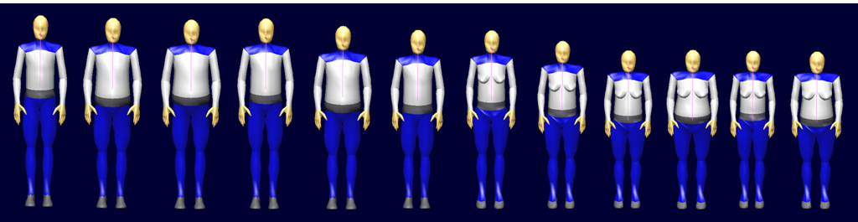
Figure 1, Ramsis manikin typology with an expected accommodation level of 95%.

2. Posture prediction simulation in RAMSIS.

Simulation of the most probable and comfortable manikin postures was done with the posture prediction model for heavy machinery of Ramsis. Postures were predicted for three main driver tasks: driving straight forward, driving twin track (backwards) and driving looking backwards (figure 2). The purpose of this was to create three overlaying visual guidelines and by this taking into account that a task may vary within a tractor cab. Tasks were defined in Ramsis by the following geometrical targets between manikin and cab geometry: feet on floor surface, hip in seat adjustment area and at least one hand on the steering wheel. View angles were unique for each task.

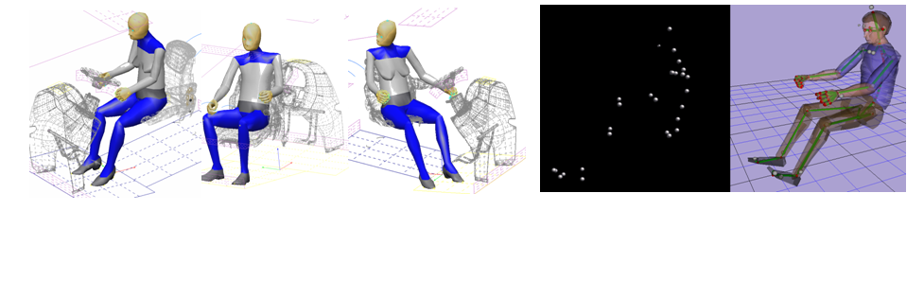
Figure 2, three main tasks: driving forwards, twin track and looking backwards at trailing implement.
Figure 3, Alias joint surfaces sphere of
Ramsis manikin and positioning of Jack manikin.

3. Translation of posture and anthropometric data between Jack and Ramsis.

Since Ramsis and Jack have different manikin models data could not be transferred freely between the two programs. Transferring manikin data of posture and anthropometry from Ramsis into Jack was achieved by the following work steps:

Ramsis manikins were recreated with respect to anthropometry with the advanced anthropometry scaling function of Jack. Since few anthropometric measurements were directly transferable, an Excel sheet adding and/or subtracting measurements of Ramsis, was used to derive useful anthropometric dimensions for Jack.

Ramsis postures were recreated by manual positioning of Jack manikins. Ramsis skeleton points were made importable for Jack with the help of the CAD program Alias. With Alias spherical surfaces representing skeleton points in *.iges format were created. These then functioned as landmarks for manually positioning of manikins in the Jack environment (figure 3).

4. Generation of comfort envelopes.

In Jack manikins were asked to visualize where they would experience the greatest comfort (in Badler, 1993) with respect to their right hand and arm, i.e. generation of comfort envelopes (figure 4). In order to derive a union comfort zone which displays the comfort of all test manikins a MatLab program was created. This MatLab program found the coordinate union of overlapping comfort envelopes by checking if a coordinate could “see” other coordinates in four quadrants. If this condition was not met the coordinate was rejected. The coordinates left, surface coordinates of the union comfort envelope, where made into visual surfaces by triangle mesh rendering in Alias.

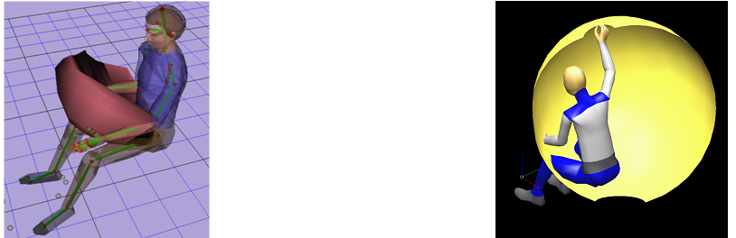
Figure 4, Jack manikin tracing comfort envelope.
Figure 5, Ramsis manikin tracing reach.

5. Generation of reach envelopes.

Manikin reach was established with respect to the right hand and arm in Ramsis as this would minimize any transitional errors caused by the manual recreation of manikins in Jack (figure 5). To establish an inner surface all test manikins could reach, all of the possible intersections of individual manikins’ reach envelopes needed to be found. In the work the CAD software Catia was used to find the smallest area enclosed by all reach envelopes corresponding to respective task.

6. Assembly of visual guideline.

The comfort and reach envelopes where finally merged into three CAD guidelines displaying limiting reach surface (red), union of comfort envelopes (green) and boundary surface created by all comfort spheres (yellow), (figure 6). Though this final part of the visual guideline, made up by the edge surface of all comfort envelopes, is less defined it has a higher probability of displaying comfort than areas outside.
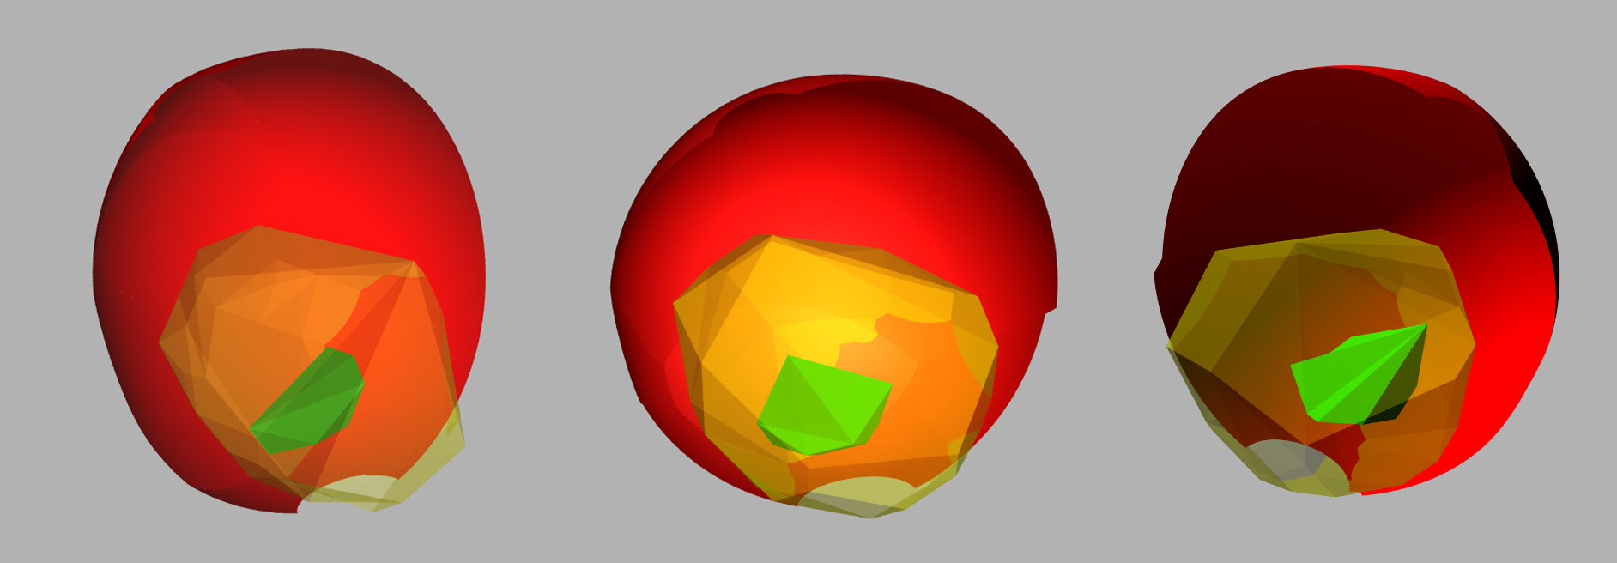
Figure 6, three visual guidelines comprised of reach and comfort envelopes of each of the three tasks.
Red

Yellow

Green

Discussion
By using the working process, reach and comfort envelopes can be derived for the specific ergonomic problem at hand. The benefit of this, as compared to more generally derived SAE guidelines and ISO standards, is an accommodation of reach better matched to the design problem. Designing with a more accurate representation of reach accommodation would better satisfy Zimmerman’s design criteria for the reduction of work-related disorders, such as back pain and hip joint arthritis.

A working process independent of general guidelines and standards has the benefit of allowing the practitioner control over each separate work step. In the illustrative case, target representatives were derived from a German population. With the working process the target group could easily be adjusted to suit other situations and markets.

One of the strengths with CAD implemented reach and comfort envelopes is that they speak a pictorial language. Visualization of ergonomic requirements has been shown to be highly beneficial as conveyor of ergonomic information to the designer (Sundin, 2001; Högberg, 2005). More specifically Moberg (2007) states that CAD implementation of reach envelopes and other ergonomic requirements can be highly useful to and appreciated by designers.

It is beyond the scope of this work to evaluate how the reach and comfort envelopes derived in the illustrative case would be received and implemented by the designers of Valtra. The following is an idea of how the reach and comfort envelopes may be used primarily at Valtra:

In this specific case, Valtra expressed a need for a simple ergonomic design tool to position commando panels and controls according to their frequency of use in their tractor cabs. By using combined/overlaid envelopes conveying reach, secondary comfort and primary comfort the designers at Valtra can easily arrange commando panels so that the most frequently used controls are located where the drivers will experience optimum comfort, as recommended by Zimmerman. The visual CAD implementation of these envelopes also means that the arrangement of controls can be evaluated more quickly with respect to other design solutions and design criteria.

References

Badler, N. (1993), Computer graphics animation and control. Simulating humans. Oxford University Press, New York, USA.

Drakopoulos D. and Mann D. (2007), An Ergonomic Analysis of the Controls Present in A Tractor Workstation, American Society of Agricultural and Biological Engineers, St. Joseph, Michigan.

Högberg, D. (2005), Ergonomics Integration and User Diversity in Product Design, Department of Mechanical and Manufacturing Engineering, Loughborough University. Doctoral Thesis.

Hsiao H., Whitestone J., Bradtmillers B., Whisler R., Zwiener J., Lafferty C., Kau T.-Y. and Gross M. (2005), Anthropometric criteria for the design of tractor cabs and protective frames, Ergonomics, Vol. 48, No 4.

Nilsson B. (2001), Maskinförares Arbetsmiljö, Prevent, ISBN 91-7522-875-0 (in Swedish).

Moberg, K. (2007), Ergonomics Requirement Verification Development at Volvo Bus Product Development, Caran AB, Waldermar Noréns gata 3, SE 417 55 Göteborg.

Seidl, A. (1994), Das Menschmodell Ramsis. Analyse, Synthese und Simulation dreidimensionaler Körperhaltung des Menschen. (The man model Ramsis, Analyse Synthesis and simulation of three dimensional human posture). Ergonomics and Human Factors, Technical University of Munich, Munich, Germany. Doctoral Thesis (in German).

Speyer, H. (2005) RAMSIS Application Guide: Test Sample & Task Definition, HUMAN SOLUTIONS GmbH, Europaallee 10, 67657 Kaiserslautern, Germany.

Sundin Anders. (2001). Participatory Ergonomics in Product Development and Workplace Design. Department of Human Factors Engineering, Chalmers University of Technology. Doctoral Thesis.

Torén A., Öberg K., Lembke B., Enlund K. and Rask-Andersen A. (1999), Tractor-driving hours and their relation to self-reported low-back and hip symptoms, Swedish Institute of Agricultural and Environmental Engineering, P.O. Box 7033, SE–750 07 Uppsala, Sweden.

Zimmerman C.L., Cook T.M. and Roserance J.C. (1997), Work-related musculoskeletal symptoms and injuries among operating engineers: a review and guidelines for improvement, Appl Occup Environ Hyg 12(7): 480-484.

