Representing the Elderly in Digital Human Modelling

Dan Högberg¹, Lars Hanson², Daniel Lundström³, Maria Jönsson⁴, Dan Lämkull^{5,6}

1. School of Technology and Society, University of Skövde, Skövde, Sweden.
2. Department of Design Sciences, Lund University, Lund, Sweden.
3. Semcon Caran AB, Gothenburg, Sweden.
4. ArjoHuntleigh R&D Center, Lund, Sweden.
5. Volvo Car Corporation, Manufacturing Engineering, Gothenburg, Sweden.
6. Department of Product and Production Development, Chalmers University of Technology, Gothenburg, Sweden

Abstract
Digital human modelling (DHM) tools have been introduced in industry, mainly in automotive, aerospace and industrial engineering, to facilitate a proactive and efficient consideration of ergonomics in the design process. The employment of DHM tools in the health care sector calls for customisation work to be carried out in order to make the tools fit the design activities. The human model, i.e. the computer manikin, needs to be modified since it has the characteristics and appearance of an able healthy young or middle-aged human, but the resident or patient is frequently an elderly person with impairments of some kind. This paper suggests concepts and structures for assigning the computer manikins characteristics of the elderly. These changes are made by the modification of anthropometric and joint range of motion data in the DHM tool, and by assigning narrative descriptions to the manikins and more age-corresponding appearances. The objective is to define a manageable number of representative manikins that will support a proactive and user-centred design process in the health care industry, and in other types of design processes for the elderly, or in an inclusive design context.

1. Introduction
Digital human modelling (DHM) tools, such as Jack, V5 Human and Ramsis, have been introduced in industry to facilitate a proactive and efficient consideration of ergonomics in the design process (Chaffin, 2005; Vogt et al., 2005). Most of the tools are used in the fields of automotive engineering, aerospace engineering or industrial engineering and are applied in the design, modification, visualisation and analysis of human workplace layouts and/or human product interactions (Landau, 2000; Chaffin, 2001; Sundin and Örtengren, 2006). The computer manikins representing the humans in the tools are mainly anthropometric replicas of healthy, young or middle-aged persons, for example in terms of looks, joint flexibility and vision, as partly illustrated in Figure 1.

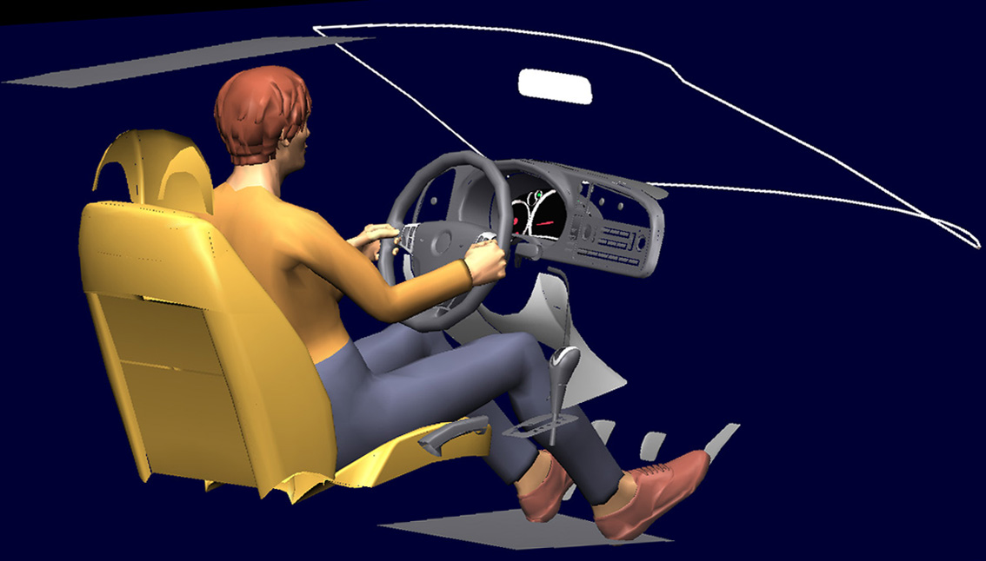
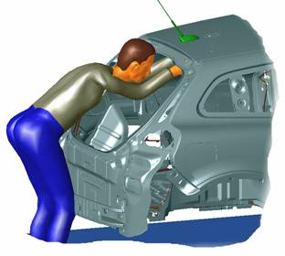

Figure 1. Digital human models for ergonomic vehicle interior and assembly design.
Courtesy of Saab Automobile (left) and Volvo Car Corporation (right)

DHM tools have recently been introduced into other application areas such as the health care industry. To some extent this industry sector can utilise the DHM tools as they function today. However, in some areas the employment of DHM tools in a health care context calls for customisation work to be carried out. One such area is the computer manikin itself, i.e. the user representation. The resident or patient is rarely an able healthy young or middle-aged human, but frequently an elderly human with some sort of impairment, e.g. leading to mobility difficulties. Thus, there is a need for computer manikins that represent the specific user groups present in a health care context. This paper suggests concepts and structures for assigning the computer manikins characteristics of the elderly. Ideally, this assignment would include physical, psychomotor, sensory and cognitive capacities. However, due to the inherent complexity, this is initially carried out in the project by utilising the anthropometric and joint range of motion adjustment functionalities in the DHM tools, and also by assigning narrative descriptions to the manikins and more age corresponding appearances. The concept of a manikin family, i.e. a limited set of computer manikins that are to represent a population, is utilised to organise the variety of the manikins. The objective is to define a manageable number of representative manikins that will support a proactive and user-centred design process in the health care industry, and in other types of design processes for the elderly, or in an inclusive design context.

2. Method
Available information about anthropometrics and mobility of elderly (Steenbekkers and van Beijsterveldt, 1998; Smith et al., 2000) is used as base data to build up the manikin family structure and to define the characteristics of each manikin. A complementary way to represent users' mobility capabilities is utilised in offering narrative descriptions to the manikins of characteristic "user types" in terms of functional mobility levels, and to a degree also in terms of personality, similar to the design methods user characters and personas (Nielsen, 2002; Pruitt and Grudin, 2003; Goodman et al., 2007). ArjoHuntleigh, who is involved in this research, has developed the Mobility Gallery, which is a communication tool basically structured according to five different levels of functional mobility (ARJO, 2005). In the gallery residents are classified according to their degree of functional mobility, from the most mobile and independent to the most dependent and entirely bedridden resident. These five mobility levels are described and labelled using alphabetical names: Albert, Barbara, Carl, Doris and Emma. Each resident is described with different personal characteristics and background details and an illustration. Residents can represent a female or male regardless of their gender specific name. Figure 2 shows Barbara as an example. This approach has proven successful by supporting communication about product users' abilities and requirements, both within the company and with people outside the company. These descriptions are in this project mapped on the manikins, conveying certain capacities and giving the manikins personality traits. This in line with conceptual ideas in Högberg and Case (2006) and Conradi and Alexander (2007).

Barbara (B)
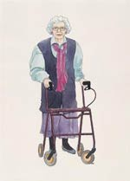
The resident is partly capable of performing daily activities independently. However, the assistance that is required is in general not physically demanding for the carer. The assistance may consist of verbal support, feedback or indications, but light physical assistance is also possible. This assistance can be given in combination with smaller aids (walking aids, support or grips and handles) or adaptations in the environment of the resident (grips and handles). Barbara’s remaining capacity should be stimulated.

Characteristics
• Uses walking frame or similar
• Can support herself to some degree
• Dependent on carer who is present in demanding situations
• Not physically demanding for carer
• Stimulation of remaining abilities (e.g. ambulation) is very important

Figure 2. Personal characteristics for Barbara to express level of functional mobility.
Courtesy of ArjoHuntleigh
3. Results
3.1 Anthropometry
A set of manikins with different sizes is defined in order to represent anthropometric diversity, based on manikin descriptions suggested in Speyer (2005). Percentile and specific values for these 12 manikins (6 per gender) are given in Table 1. Three body dimensions per manikin are defined. This is based on the theory that the definition of the characterizing property of stature, proportion (ratio of the sitting height and length of the legs) and corpulence of an individual is sufficient to predict all other body dimensions for this person (Flügel et al., 1986; Bubb et al., 2006). This concept entails that all other body dimensions are defined by the anthropometric functionality in the DHM tool itself, using existing correlation data to these three key variables. The percentile values in Table 1 can be applied on different anthropometric databases in order to represent the targeted population. In this case anthropometrics data for Elderly British Males and Females in the age group 75+ is used (Smith et al., 2000) leading to the specific values in Table 1. This selection was made due to lack of current data of Swedish elderly. Since data for waist circumference was not available for the selected user group, weight was used to signify corpulence. This assumption is believed to be adequate due to the relatively high correlation between the two dimensions (Kroemer et al., 2001).

Table 1. Percentile and specific values for manikin family.

3.2 Mobility - Range of motion
In order to modify the manikins' joint range of motion (ROM) to more appropriately represent elderly people and the different mobility levels as defined in the Mobility Gallery, ROM data for elderly, obtained from Older Adultdata (Smith et al., 2000) is entered in the DHM tool. Table 2 shows angular data for shoulder extension and flexion, as an example. As some residents, particularly Doris and Emma, have very little own activated mobility an additional "Supported" angular range was added, representing movements that may be achieved with the aid of a carer or an assisting product or machine. As this study is in progress, the specific data in Table 2 is only preliminary at this stage and the main outcome this far is the approach of how to structure ROM data.

Table 2. Preliminary range of motion data for Mobility Gallery residents.
3.3 Manikin family structure
In principle, the layout presented in 3.1 and 3.2, with 12 different manikins in terms of anthropometrics (6 per gender) and 5 mobility levels, make up to 60 different manikins, which is arguably not a manageable number if no automatic evaluation method in the DHM tool can be utilised. However, all these manikins are unlikely to be applied for any specific design task but rather a subset thereof. Which manikins to use depend on the current design task. For example, if one were to design a doorway and want to define the required door height to accommodate the entire manikin family, only one manikin would be required, i.e. the tallest (Speyer, 2005). In this case that would be manikin M3 in Table 1 (and any mobility level). Similarly, if one would be to design a product where all anthropometric variations need to be considered, and the worst case in terms of mobility level, one could use all "Emma", i.e. 12 manikins. So one challenge is to define the limiting user/users for the design task and keep the number of manikins low, in order to reduce the design and evaluation effort required.

3.4 Characteristics and appearance
Again, since this research is in progress no final results can be presented but rather the chosen approach towards the result regarding characteristics and appearance. In order to assign the mobility characteristics as defined in the Mobility Gallery on the manikins, the resident information will be attached to the specific manikin, as well as additional information such as anthropometry and ROM data. This enables the DHM tool user to retrieve the resident information (text and illustrations, as shown in Figure 2) when highlighting the manikin. Still, this will not change the appearance of the actual manikin in the DHM software. To reach this, as we believe, important step for supporting understanding and empathy of the user one is designing for, next objective is to alter the appearance of the manikin to have a more age-corresponding appearance. Due to the lack of any visualisation functionality to alter age related appearance of the manikin in today's DHM tools (such as those mentioned in the introduction) this step is harder to realise. However, some human visualisation tools, developed for other purposes than ergonomics design, offer the possibility to alter age appearance, e.g. the illustration software Poser 7. Figure 3 shows an attempt to illustrate the resident Albert using this functionality in Poser 7. Current work in this research project involves trying to combine functionality in Poser 7 and the DHM tool V5 Human to facilitate manikins with age corresponding appearance within a DHM tool made for ergonomics design.
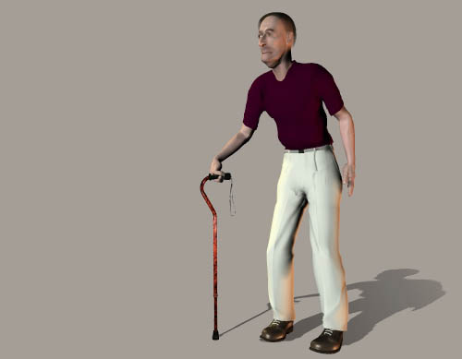

Figure 3. Illustration of Albert as an elderly manikin.

4. Discussion
The rationale for the work presented in this paper is similar to the ideas behind the development of the inclusive design tool HADRIAN, which also aims to support designers at conceptual design stages to consider and evaluate ergonomics (Marshall et al., 2004). HADRIAN also incorporates data of individuals, albeit being based on actual individuals rather than on statistical data and experience-based descriptions as in the Mobility Gallery. Both approaches are important steps towards improving design tools for designing for people, and particularly for people who are sometimes considered a less important group of customers when designing products, systems and environments.
Based on literature review, observations and interviews with designers, Goodman et al. (2007) conclude that designers prefer user information that is quick and easy to find and use, visual and stimulating, flexible and open-ended, and that relate clearly and concretely to design issues. This is in line with the ideas behind the design tool concept presented in this paper. Based on the assumption that one uses a CAD tool to design, the possibility to incorporate the human in the "virtual world" enables visualisation and evaluation of interactions in the product-human system. Enabling the manikins to be adapted to better represent the eventual users enhances this functionality. Goodman et al. (2007) discuss advantages in using personas for the description of user characteristics as a method to create better understanding among designers and engineers for the end users and their needs. This view is in line with the Mobility Gallery utilised in this project.
The objective to represent both anthropometric and mobility variability within a limited set of manikins calls for a sensible balance between precision and usability. Too few manikins would in many cases give too rough analysis results. An example of this would be (the common way) to use only one small and one large manikin when evaluating a design, which from an anthropometric point of view is an inappropriate approach for many design problems (Robinette and Hudson, 2006). Too many manikins would make it harder to manage and convey the diversity of the manikin family, and it would cause analyses to be more complicated and time consuming to carry out, particularly if no kind of automatic evaluation method can be utilised. This research aims to propose a "reasonable" number of representative manikins (i.e. 6 per gender) and a pragmatic approach of how to employ these in a health care design setting. The complexity involved in considering anthropometric variation in design problems, such as the design of workplaces or vehicle interiors, is for example described by Roebuck et al. (1975) and more recently by Robinette and Hudson (2006). The A-CADRE manikin family consists of anthropometric descriptions of 17 manikins (Bittner, 2000). This set of manikins has shown to successfully represent the user population (Bittner, 2000; Högberg and Case, 2007). However, in this project A-CADRE was considered, at least initially, to consist of too many manikins for meeting the objective of being easy to manage and convey.
The material presented in this paper should be considered a prototype method since the research is in progress. In due time the manikin family and its utilisation is to be improved when more experiences of its structure and application are drawn.

Acknowledgements
This paper is partly a result of the research project "Visualisering av brukarkaraktäristik vid produktutveckling inom fordons- och hälsoindustrin" which is carried out within Virtual Ergonomics Centre (www.vec.se) and is financially supported by the Knowledge Foundation (KK-stiftelsen) in Sweden under the grant no. 2007/0137 and by the participating organisations. This support is gratefully acknowledged.

References
ARJO (2005). ARJO Guidebook - for architects and planners. Eslöv, Sweden, ARJO.
Bittner, A. C. (2000). A-CADRE: Advanced family of manikins for workstation design. XIVth congress of IEA and 44th meeting of HFES, San Diego. 774-777.
Bubb, H., Engstler, F., Fritzsche, F., Mergl, C., Sabbah, O., Schaefer, P. and Zacher, I. (2006). The development of RAMSIS in past and future as an example for the cooperation between industry and university. Int. J. of Human Factors Modelling and Simulation 1(1): 140-157.
Chaffin, D. B. (2001). Digital human modeling for vehicle and workplace design. Warrendale, Society of Automotive Engineers.
Chaffin, D. B. (2005). Improving digital human modelling for proactive ergonomics in design. Ergonomics 48(5): 478-491.
Conradi, J. and Alexander, T. (2007). Modeling personality traits for digital humans. Warrendale, Society of Automotive Engineers. SAE Technical Paper 2007-01-2507.
Flügel, B., Greil, H. and Sommer, K. (1986). Anthropologischer atlas: grundlagen und daten. Berlin, Verlag Tribüne. (in German)
Goodman, J., Langdon, P. and Clarkson, P. J. (2007). Formats for user data in inclusive design. Human Computer Interaction International 2007. C. Stephanidis, Ed., Springer. Universal Access in HCI, LNCS 4554: 117-126.
Högberg, D. and Case, K. (2006). Manikin characters: user characters in human computer modelling. Contemporary Ergonomics. P. D. Bust, Ed. London, Taylor & Francis: 499-503.
Högberg, D. and Case, K. (2007). Predefined manikins to support consideration of anthropometric diversity by product designers. Human Computer Interaction International 2007. V. G. Duffy, Ed., Springer. Digital Human Modeling, LNCS 4561: 110-119.
Kroemer, K. H. E., Kroemer, H. B. and Kroemer-Elbert, K. E. (2001). Ergonomics: how to design for ease and efficiency. Upper Saddle River, Prentice Hall.
Landau, K. (2000). Ergonomics software tools in product and workplace design - A review of recent developments in human modeling and other design aids. Stuttgart, Germany, ERGON GmbH.
Marshall, R., Case, K., Porter, J. M., Sims, R. E. and Gyi, D. E. (2004). Using HADRIAN for eliciting virtual user feedback in 'design for all''',. Journal of Engineering Manufacture 218(B9): 1203-1210.
Nielsen, L. (2002). From user to character - an investigation into user-descriptions in scenarios. DIS´02, Designing Interactive Systems, London. 99-104.
Pruitt, J. and Grudin, J. (2003). Personas: practice and theory. Conference on designing for user experiences, San Francisco, ACM Press New York. 1-15.
Robinette, K. M. and Hudson, J. A. (2006). Anthropometry. Handbook of human factors and ergonomics. 3rd ed. G. Salvendy, Ed. Hoboken, John Wiley & Sons: 322-339.
Roebuck, J. A., Kroemer, K. H. E. and Thomson, W. G. (1975). Engineering Anthropometry Methods. New York, John Wiley & Sons.
Smith, S., Norris, B. and Peebles, L. (2000). Older adultdata - the handbook of measurements and capabilities of the older adult. London, Department of Trade and Industry.
Speyer, H. J. (2005). Ramsis - Application guide: Test sample & task definition. Kaiserslautern, Human Solutions GmbH.
Steenbekkers, L. P. A. and van Beijsterveldt, C. E. M., Eds. (1998). Design-relevant characteristics of ageing users, Delft University Press, The Netherlands.
Sundin, A. and Örtengren, R. (2006). Digital human modeling for CAE applications. Handbook of human factors and ergonomics. 3rd ed. G. Salvendy, Ed. Hoboken, John Wiley & Sons: 1053-1078.
Vogt, C., Mergl, C. and Bubb, H. (2005). Interior layout design of passenger vehicles with RAMSIS. Human Factors and Ergonomics in Manufacturing 15(2): 197-212.

Corresponding author: Tel.: (+46) 500-448549; Fax: (+46) 500-448599; E-mail: dan.hogberg@his.se

